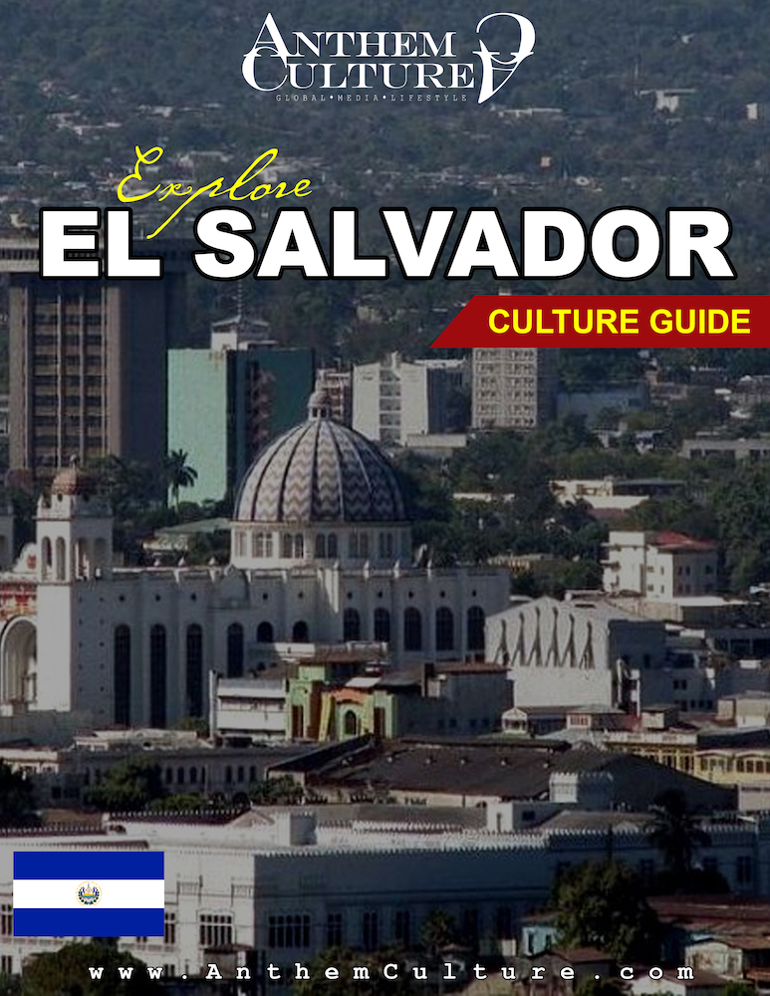

Architecture

Architecture in El Salvador has significant European influence, as can be seen throughout the country in the design of many colonial churches, museums, theatres, etc.
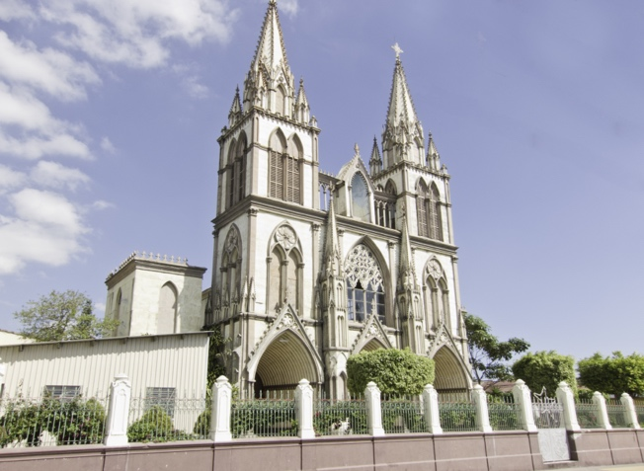
In rural areas of El Salvador, houses are primarily made of adobe, which has many economic advantages in addition to simplifying the construction of the houses. One popular house feature includes a corridor, or large porch attached to the front of these houses, on which people tend to spend most of their time.

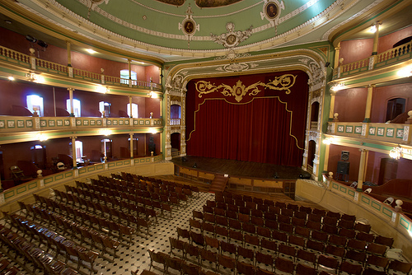
In colonial periods, upper class urban houses were designed with outdoor space in the center of the house, to added privacy. Although in modern house design, this space is now moved to the front of the house, often in the form of a garden, privacy is increased thanks to walled communities and non-street visibility. The further down in the class system you move, the more visibility and less security is seen for housing. Housing for the poor is often made of discarded materials such as cardboard or sheet metal.

El Salvador has many architectural landmarks in various cities. In the capital, San Salvador is the Iglesia El Rosario, built in 1971 and considered one of the most visually interesting churches. Its interior walls are full of color thanks to the stained glass murals designed by Ruben Martinez. This church is also famous for being the resting place to José Matías Delgado, the father of Central American Independence.
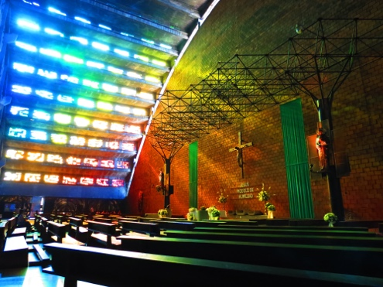
Another notable landmark can be found in El Salvador’s commercial center, Santa Ana. El Teatro Nacional de Santa Ana was completed in 1910, designed by Domingo Call, Francisco Durini, and Cristóbal Molinari. This popular theatre has an elegantly decorated interior as well and plays host to numerous performances and exhibits year round.

APPRECIATE CULTURE.

ART

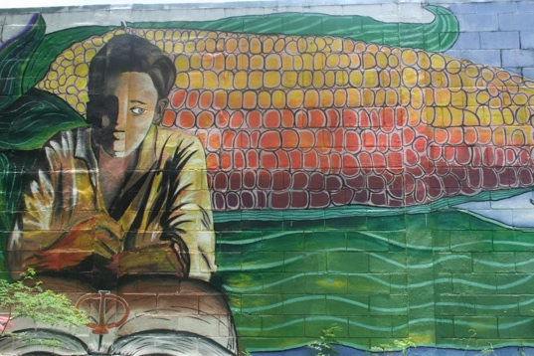
Thanks to its location, El Salvador draws significant cultural influence from both Spain and Mexico.

Modern Salvadoran art talent is developed in La Palma, a northern town in El Salvador, where, even in the past, artists live and train.

Traditional Salvadoran art began with Fernando Llort, whose paintings had two main attributes: simple and colorful! The traditional style of art also contains the use of animals, flowers, trees, houses, and other common objects.

The National Art Museum ‘El Museo de Arte de El Salvador’ is located in the capital, San Salvador.
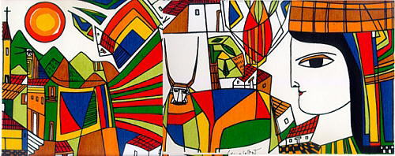
APPRECIATE CULTURE.

FASHION

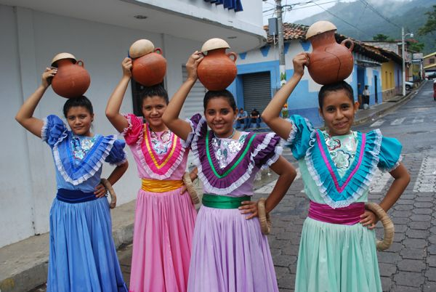
El Salvador’s unique landscape and climate, the country’s fashion trends, both modern and traditional, are characteristic of the area that it comes from.

In urban areas of El Salvador, traditional clothing is mainly only worn for religious purposes, holidays, or festivals. Modern styles mirror the casual look of the Western world.

In rural areas, traditional clothing can still be seen. Clothing in the past was developed to be functional for work and labor. Women’s fashion is typically seen with colorfully adorned accessories such as scapular, shawl, and cotton headscarf. Men’s fashion includes a cotton suit or shirt.

El Salvador’s fashion includes bright and colorful designs with bold patterns. Their fabrics can range from knits with regional patterns, cotton-polyester blends, and cottons. With the hot Caribbean climate of Central America, lightweight fabrics are preferred. Rain-resistant clothing is common during the extensive rain season May-October.

APPRECIATE CULTURE.

FOOD

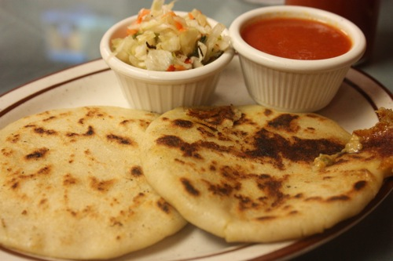
El Salvador food is derived from Latin America so many of their meals and diets are very similar if not the same. Their Latin-based cuisine draws influence from both Indigenous Pipil people and Spanish people primarily. The main ingredients seen in the Food of El Salvador are maize (corn) and seafood, thanks to the country’s stretching coastline.

One of the main dishes eaten around El Salvador is called Pupusa. Other popular dishes include Pollo Encebollado as well as famou cheeses including Queso Duro, Queso Fresco, and Cuajada.

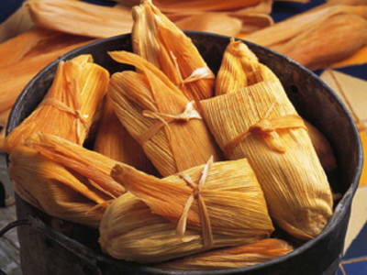
El Salvador is also know for different types of Tamales, whose fillings can range from stuffed beans, stuffed meat, and even Travelers Tamales, or Ticucos.

In modern El Salvador, popular drinks include soft drinks, often among the youth, as well as coffee, a frequent drink of all ages, as well as being the country’s top export.

APPRECIATE CULTURE.

Language

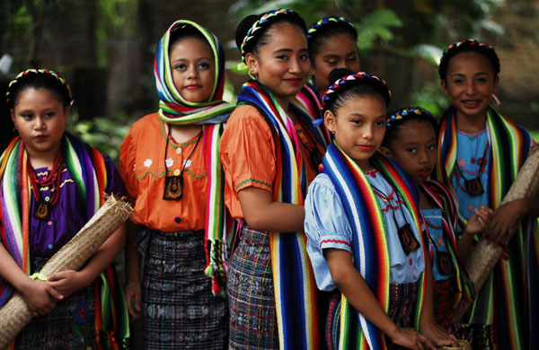
The official language of El Salvador is Spanish, thanks to the early Latin American influence. The accent of Salvadorans is similar to that of Honduras and Nicaragua, just spoken at a slower pace.

The Pipil, or Nawat, language was spoken by the ancestors of the country, but is now only survived by less than 1% of the population, mainly elders as it has no obligation academically or socially. This Uto-Aztecan language originated from Nahuatl region and is still widely spoken in Mexico. It was developed in the Nahua-Pipil communities upon arrival of Spanish colonialists.

English is taught as their secondary language. Globalization lead to the wide spread of English, which is also in the business world.

APPRECIATE CULTURE.

Literature

The origin of literature in El Salvador is not just one defined series of events, but moreso described as spontaneous and even accidental.

Literary activity relates to the overall rise of cultural activity and education during the Enlightment era seen around the world. During the colonial era, Theatre was a popular form of literature and entertainment. The main theatrical topics included religion and comedy. As Literature continued to develop, literature for the sake of entertainment became less prominent, being replaced by speech and journalistic writing. During this major political era, more writing opportunities were available in these fields. Towards the latter twentieth century, literature became more of a reflect on the past, re-examining the history of El Salvador.
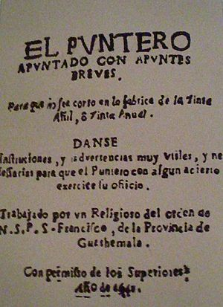
Popular traditional literature pieces include “El puntero apuntado con apuntes breves,” written by Juan de Dios del Cid, who is also credited with creating the first printing press in El Salvador, on which he published his work. “Carta de Relación” is another popular literature piece is written by Pedro de Alvaradio, a conquistador, who narrates major events in the conquest of the Americas.

APPRECIATE CULTURE.

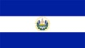
Music

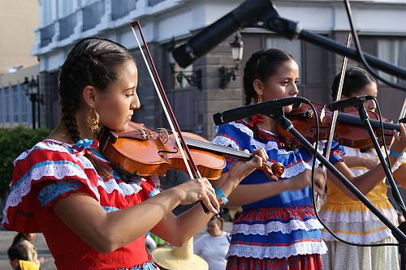
El Salvador has diverse music thanks to it’s many influences. In modern El Salvador, the popular styles of music include Salvadoran Cumbia, Salvadoran Hip Hop, Rock, and Native Mesoamerican Indigenous music, that of which has had a large impact on the music of both modern day and traditionally. Today, El Salvador draws a lot of musical influence from Western societies as well as Latin America, but traditionally, Lencu, Pipil, and Spanish styles dominated these influences.

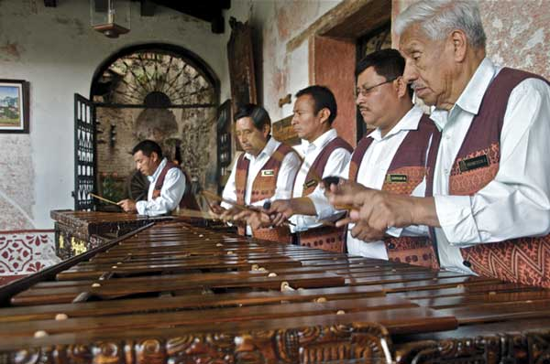
El Salvador folk music often carries a theme of satirical or rural, commonly played with the Xylophone, one of the main instruments used in the music. In the past, the Marimba, a type of Xylophone, became popularized in El Salvador after being introduced by African slaves.

The first radio stations of El Salvador were completely government-owned. The regulated music styles allowed to stream included waltz, foxtrot, rancheras, soones, songos, and tangos.

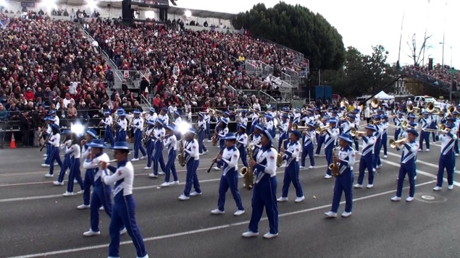
Settlement played a major role in the development of music in El Salvador. Although located in Central America, early on, Europeans predominantly inhabited the country’s northern areas. This European influence on northern El Salvador leads to the distinctive sound that survives in the area even today.

The same was true in the past as it is today: a vital factor in El Salvador’s youth culture is participation in marching band, including school and military bands. Marching bands are seen a variety of events, celebrations, and even for small activities. You can still see the country’s traditional instruments being played in throughout.

APPRECIATE CULTURE.

Sports

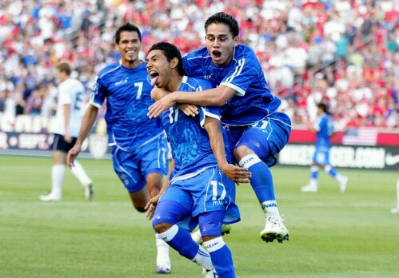
Sports in El Salvador are the country’s main source of entertainment; more specifically Football (Soccer), which is the most popular sport in not only El Salvador, but in all of Central America.

El Salvador is actually home to the largest football stadium in Central America, Estadio Cuscatlán, which is located in the capital of San Salvador and the home of El Salvador National Football Team, amongst many other teams.

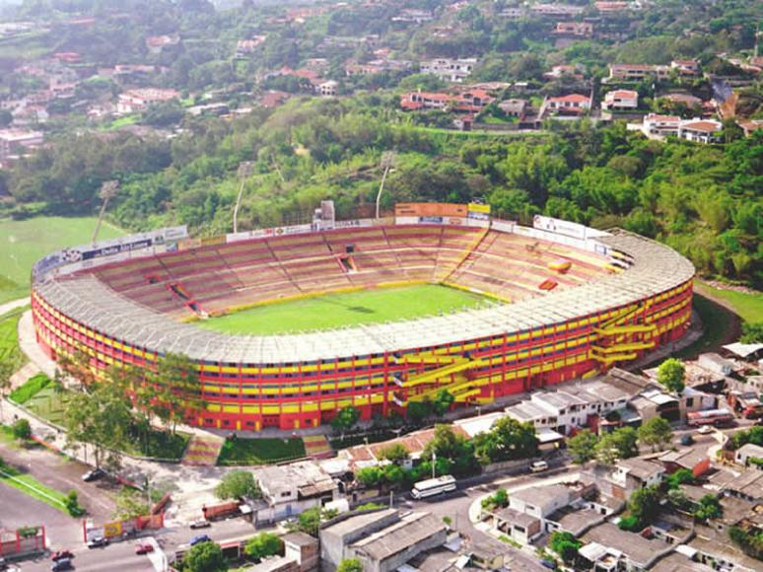
As other popular sports include basketball, volleyball, swimming, etc., El Salvador has participated in numerous global scale sporting events such as the FIFA World Cup and the Summer Olympics, sending athletes to compete since 1968.

APPRECIATE CULTURE.

